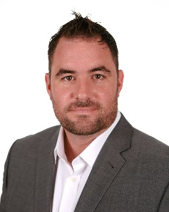
Biography:
Frank Townsend, is the President of Patriot Shotcrete. Patriot Shotcrete is a Disabled Veteran owned small business. Previously, he was the Vice President of Operations for Superior Gunite. He is a Civil Engineer graduate of Worcester Polytechnic Institute, in MA, and Master’s Degree from the University of Missouri. Frank served as an Army Engineer Officer who deployed to numerous deployments from Central America to the Middle East.
He then worked in the Heavy Civil field for Conti Federal Services, Schiavone Construction and Tutor Perini as a Superintendent and Project Manager.
Frank is an active member of American Concrete Institute(ACI) and the American Shotcrete Association(ASA). Currently serves as a Committee Chair for ACI and President of ASA. Frank is a member of the Moles and Beavers (Heavy Construction Organizations), American Society of Concrete Contractors, as well as others. He has been Awarded the US Army Corps of Engineers deFluery Medal and Engineer News-Record New York’s “Top 20 under 40” design and construction leaders.
Some notable projects include below grade wall at the World Trade Center, New York; Structural Shotcrete on the East Side Access Project, New York; Henry Hudson and Bayonne Bridge in New York, just to name a few.

